Godspeed manual

2014 April 12

Contents

1 Main Features 3

1.1 Prerequisites 3

1.2 Supported FTP services 3

1.3 Limitations 3

2 GODspeed 3

2.1 Quick Use Tutorial 3

2.2 Connections 4

2.2.1 Add New Connection 4

2.2.2 Edit Connection 6

2.2.3 Remove Connection 7

2.2.4 Connect 8

2.2.5 Disconnect 8

2.3 File explorer 8

2.3.1 Common functionalities 8

2.3.2 FTP screen 8

2.3.3 Recognitions 8

2.3.4 Compressed Files 9

2.3.5 Remote Copy (NAS to FTP) 9

2.3.6 Function buttons 9

2.4 Commands 9

2.4.1 Calculate occupied space 9

2.5 Options 9

2.5.1 Settings 9

2.5.2 Statistics 9

2.6 Help 10

2.6.1 Quality improvement program 10

2.7 Messages 10

2.8 Hotkeys 10

3 Troubleshoot and FAQ 12

3.1 Black Screen appears when i launch the software, what to do? 12

3.2 What is JTAG / RGH? 12

3.3 What is GOD? 12

3.4 Can i help in the development or have the source code? 12

3.5 Why there is no remaining space shown? 12

3.6 Something crashed, what should i do? 12

3.7 I have dumb questions to ask, can i ask them? 12

4 Contacts 13

# Main Features

* FTP connection to consoles with FreeStyle Dash and XeXMenu
* Instead of cumbersome IDs real names and thumbnails are displayed to see what is what
* Automatic Gamertag and Gamer picture extraction from profiles
* Automatic game information gathering from Game folders and online searches
* Manual game information gathering from profiles
* Automatic SVOD package recognition (DLCs, Title Updates, gamesaves, etc.)
* STFS package browsing, content extraction/injection
* Folder size calculation on FTP (most annoying deficiency of Total Commander)
* Content-aware folder creation
* Remote Copy support between NAS and FTP (Telnet and LFTP required)
* Compressed file support

## Prerequisites

* XBOX device must be JTAG and RGH enabled in order to support the file copy.

## Supported FTP services

* MinFTPD
* Freestyle Dashboard
* XeXMenu
* Playstation 3 (built-in)

## Limitations

* The left pane can be used for local file system browsing only
* The right pane can be used for FTP browsing only
* Limited configuration possibilities
* Edit action works on FTP connection settings only

# GODspeed

GODspeed is a Total Commander like FTP client designed to fasten and clarify file management of JTAG/RGH/DevKit Xbox 360 consoles.

In order to help everyday console gamers life, the GODspeed is here to help copy softwares from and to your XBOX 360 or Playstation 3 via FTP.

## Quick Use Tutorial

* Double click or Enter on the New connection... item in the Connections pane to create a new connection.
* Double click or Enter on a connection item to connect to an FTP.
* Browse into your Content folder and wait for your profiles to be recognized. Result will be cached.
* Browse into your Games folder and wait for your games to be recognized. Result will be cached.
* If you see a game with a green Xbox icon and - probably - trimmed title, it means the game isn't installed on your console. As a fallback GODspeed checked the title on covers.jqe360.com and found the displayed title.
* If you see a game with the name Unknown game it means GODspeed couldn't find it on covers.jqe360.com either. (Or jqe360.com lookup has been switched off)
* Right click and select Rename if you want to change an item's title.
* Right click on a profile and select Recognize Titles from Profile to update your cached game information based on the selected profile.u It's much more accurate than covers.jqe360.com but significantly slower.
* To browse profile content select Open profile, or if it's a file Double click or Enter on it. Every change you make on that profile is in-memory and will be saved only if you press the Save and Close button. If you open a profile via FTP a temp file is used and it will be uploaded back automatically after Save and Close.  
  **USE IT WITH CAUTION!**
* Network shares are not supported. If you want to connect to a NAS map a network drive first.
* If you have a NAS and you want copy files between it and your Xbox, you can speed up your transfer by turning the Remote Copy feature on. However this is going to work only if your NAS supports Telnet and LFTP.
* You can use the Total Commander's most common hotkeys in GODspeed as well like the F keys, Alt+F1/F2 for drive change, Space and Ctrl+L for space consumption calculation, etc.
* If the application stops working and throws an unexpected error please press the Report button to report the error to help to fix it ASAP. Thank you!

## Connections

### Add New Connection

1. Double Click on **New Connection..**

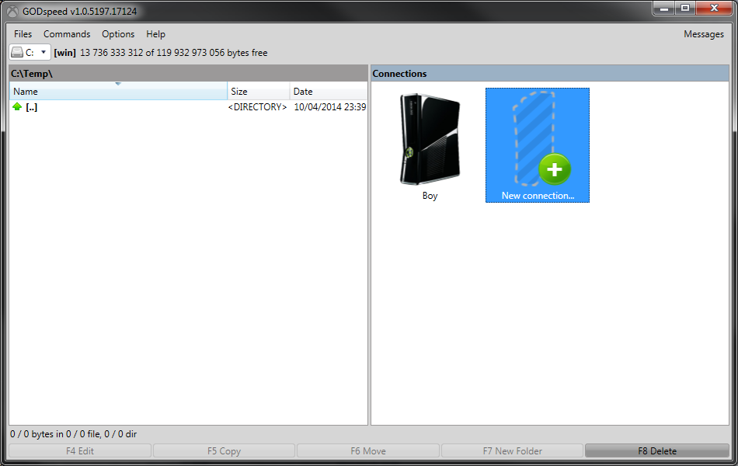

1. Add **Connection Name**

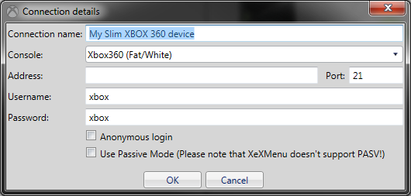

1. Select **Console Type**

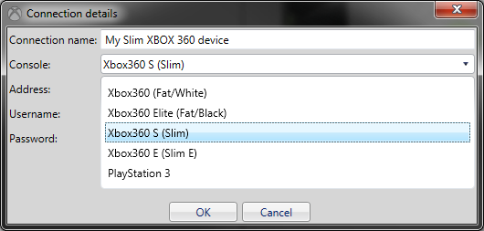

1. Fill in **Address and Port**

To find the address of your device Press the right analog ont he joysting in Freestyle menu, or go search trough settings for an IP address. Port is usually 21 for every FTP.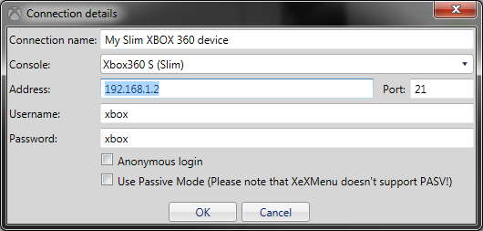

1. Specify **Username** and **Password** for the FTP

For XBOX 360 devices the devault is xbox/xbox, no need to change it  
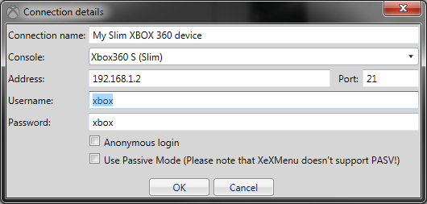

1. Advanced Settings

If there is no username and password you can set **Anonymous login**.

If the fsp server requires, **Use Passive Mode** can be enabled. This can also help with firewall settings.   
Please note that XEX menu does not support it Passive mode.

1. Click **OK** to save the connection.
2. The new connection will appear on the **Connections screen**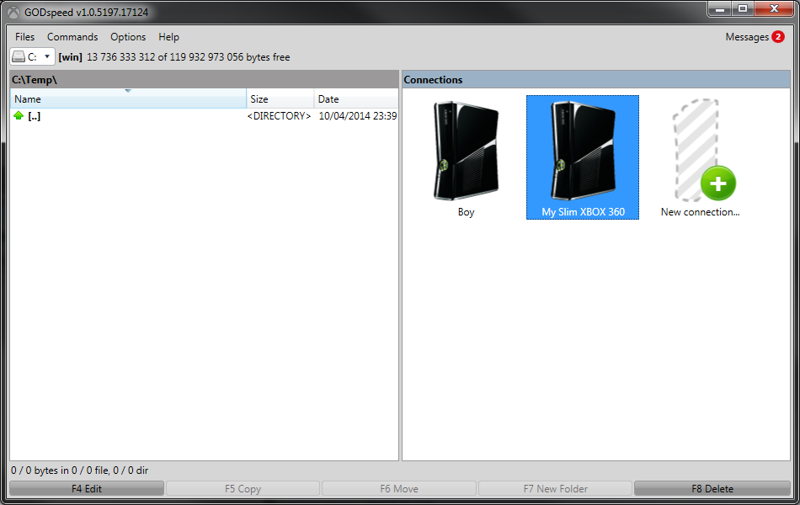

### Edit Connection

1. To edit existing connection select the connection icon, for example: „My Slim XBOX 360” and **Press F4** or The **F4 Edit button** in the bottom left corner of the application window.
2. Rename the connection or **change any settings**.  
   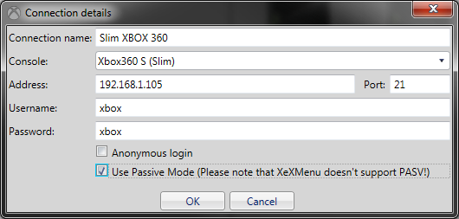
3. Press **OK** to save the modified Connection details.
4. The changed connection will appear on the **Connections screen**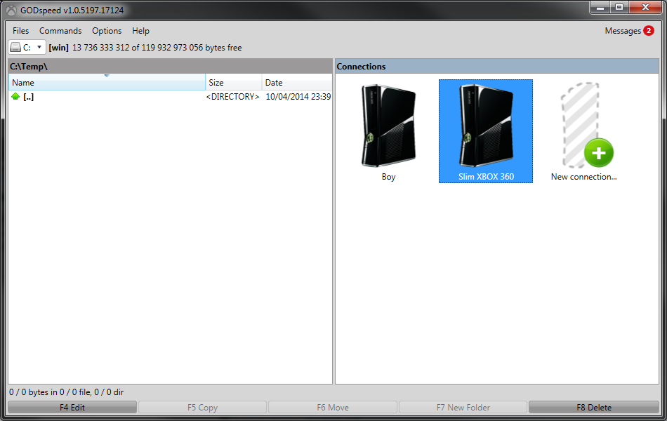

### Remove Connection

1. To remove existing connection select the connection icon, for example: „Slim XBOX 360” and **Press F8** or the **F8 Delete button** in the bottom right corner of the application window.
2. Press **Yes** to Delete the connection  
   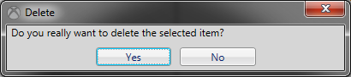

### Connect

1. Double Click on the Connection item.

If the connection was succesful, the right side of the application will switch to FTP view.  
It will remember the last used folder and will reutrn to it on reconnect.

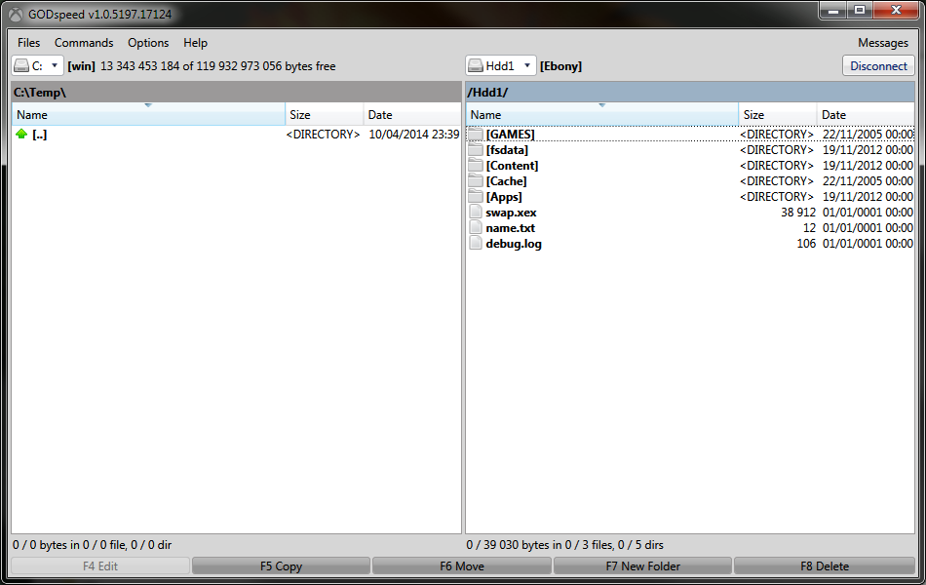

If the connection settings are wrong or a firewall blocks the conection, or a game is running on the device, the following message will appear: 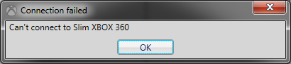

### Disconnect

To Disconnect from the FTP, you can press **Disconnect button** in the upper right corner, and the software ill return to the **Connections screen.**

Otherwise you can simply exit the application and it will disconnect.

## File explorer

### Common functionalities

### FTP screen

### Recognitions

Certain type of folders are recognized and the software has extended functionalities to handle them better.

#### Game and Games folder recognition

Each game is tried to be recognized, an image and name is downloaded from MISSING LINK.

Usually every GOD game folder has an alpha numeric string as its name like „524000000” which can be recognized.

Game folder consists of only Zeroes on XBOX. It helps to idenfity which is the main game folder on the device. Usually it is „//HDD0/Content/Games”.

#### Profile recognition and editing

Profiles can be opened and Edited.

Precautions advised! Best to do a Backup of the profile before editing!

Achievements and other profile related files can be viewed, downloaded, uploaded and saved.

### Compressed Files

### Remote Copy (NAS to FTP)

TODO

### Function buttons

## Commands

### Calculate occupied space

Both File and FTP browser screens has SIZE columns, but these values are empty and or showing the type of the given item until you press **Calculate occupied space**(Control + L) int he Commands menu.

File size is shown in Bytes to show precise amounts instead of rough Gigabytes or Megabytes.

This size information can be useful to identify if the size of the remote folder is different from the local.

Calculate occupied space cn help to identify/manually calculate the remaining hard drive capacity of your device.

## Options

### Settings

### Statistics

## Help

### Quality improvement program

## Messages

You can eventually get messages and such, about opinion and such.

It will notify users with a number in the corner in order to show new messages.

**Message links** can be opened with the **small circle** or   
Messages can be **deleted/unsubscribed** by the small **x button**.  
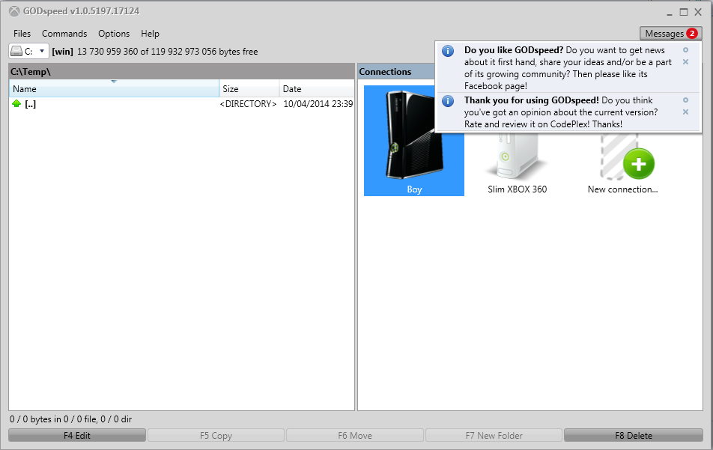

## Hotkeys

|  |  |
| --- | --- |
| Functionality | Key |
| Selection modifiers | Insert OR Space OR Shift + UP/DOWN |
| Invert selection | * (Multiply) |
| Select all | Control + A |
| Go to First item | Home OR Shift + Home |
| Go to Last Item | End OR Shift+ End |
| Refresh | Control + R |
| Calculate occupied Space | Control + L |
| Go one directory Up. | Backspace |
| Cancel | Excape |
| Rename Title | Shift + F6 |
| Rename File or Folder | Control + Shift + F6 |
| Edit | F4 |
| Copy | F5 |
| New Folder | F7 |
| Delete | F8 |
| Change Drive in File pane | Alt + F1 |
| Change Drive in FTP pane | Alt + F2 |

# Troubleshoot and FAQ

## Black Screen appears when i launch the software, what to do?

Press Alt, Left, Left, Down, Enter ont he main window in order to open Options Screen.

Tick the **Disable Custom Window Chrome\*** checkbox on the **Appereance tab**, press **OK** and restart the software in order to get rid of this problem.

## What is JTAG / RGH?

Please Google it!

## What is GOD?

Game On Demand, a sort of package for XBOXes.

## Can i help in the development or have the source code?

Yes, go to <http://godspeed.codeplex.com>. Thank you in advance!

## Why there is no remaining space shown?

## Something crashed, what should i do?

## I have dumb questions to ask, can i ask them?

# Contacts